Kol Simcha Torah Gazette
For parshas vayeishev 5786
Vol 10 Issue 10 (Whole #476) 23 Kislev 5786/ December 13, 2025
Printed L’illuy nishmas Nechama bas R’ Noach, a”h
For a free subscription, please forward your request to keren18@juno.com
Past emails can be found on the website ShabbosStories.com under Brooklyn Torah Gazette
How to Live in Very Difficult
And Challenging Times
By Daniel Keren

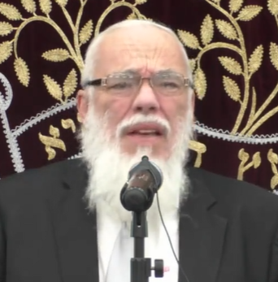
Rabbi Sholom Smith

One of the featured speakers at the recent Flatbush Veterans’ Day Hakhel Event that was held in the Agudas Yisroel of Madison last month was Rabbi Sholom Smith, internationally renowned Maggid Shiur and author of ten volumes based on the Torah teachings of his rebbi muvhak – Rav Avrohom Pam, zt”l. The title of his lecture was “Dealing with Challenges in Life: Practical, Meaningful and Effective Guidance.”
He began his talk with the remark that we are living in very difficult times. It seems like we get through one problem and are immediately confronted with another challenge. He noted that Chumash Bereishis (the Book of Genesis) is the longest of all the five books in the Chumash. And, yet it has only three (of the 613) mitzvas. Yet, our Sages [of blessed memory] call Sefer Bereishis – the Book of Yesharim (the upright or straight ones) because it details the lives of the Avos (our Patriarchs) who were called “yesharim” (the upright or straight ones) for their integrity and uprightness.
Rabbi Smith said that we learn “maisos avos simonim l’banim” that the actions of our avos are to be signs for their children in all the generations that have followed to emulate. In the recent parsha Chaya Sara, Rashi says that all of Sara’s life was equally good. She was 15 when she got married to Avram who was then 25. As the year quickly passed, she had no children and saw her friends getting married and having children and then enjoying the birth and the weddings of their grandchildren.
And her husband was disparagingly called by their neighbors - the “Ivri”, from the “other side” (i.e. not normal.) Despite the difficulties of her life, she understood that the show must go on. Despite twice being abducted from her husband, first by Paroah and then by Avimelech, king of the Plishtim (Philistines), she knew the show must go on. Eventually, she was miraculously blessed by Hashem with the birth of Yitzchok.
Avraham Avinu, her husband successfully achieved success in overcoming the 10 nisayon, (spiritual challenges) that Hashem gave him – including the last - the Akeidas Yitzchok (the Binding of Isaac on the alter) and he come home only to discover that his beloved wife Sara has died. Instead of collapsing, he recognized that the show must go on. Instead of telling his servant Eliezer to handle the details of the burial, Avrohom insisted on personally negotiating with the leaders of Ches and with Ephron the Hittite.
Eliezer was a very important person. Avrohom instructed his servant to perform one of the most important tasks – that of finding a suitable wife for his son Yitzchok. Eliezer was completely devoted to his master Avrohom. Despite Avrohom’s rejection of Eliezer’s suggestion that perhaps Yitzchok could marry his loyal and dedicated servant’s own daughter, Eliezer didn’t quit his job as Avrohom’s servant. He realized that the show must go on. He indeed risked his life to carry out Avrohom’s request with all of his kochos (energies.)
We learn Rabbi Smith emphasized that the Satan (the personification of the evil inclination) told Sara what Avrohom had done to her beloved and only son Yitzchok at the Akeida. The shock was so great that she actually passed away. But we have to know that she didn’t die because of that diabolical shock from the Satan. Indeed, Rashi explains that all of the years of Sarah were equally good. Absolutely, nothing was missing from the life of Sarah. It was destined that she would die on the day that she was nifteres.
Bilaam [the wicked Prophet of goyim] desired to curse Klal Yisroel. Hashem sent a malach (an angel) to stop Bilaam from going on his evil mission. The donkey of Bilaam saw the angel with the sword and tried to stop his master from continuing on his journey to curse the Jews. Rabbi Smith explains that it wasn’t a malach of destruction confronting Bilaam. Rather it was an angel of rachamim (mercy,) sent by Hashem to save Bilaam from disaster. Had Bilaam actually cursed the Klal Yisroel, it would have resulted in the total destruction of the world and of course Bilaam himself.
We are, Rabbi Smith said, living in very difficult times. Once when asked about a particular difficult situation, Rabbi Berel Wein of blessed memory answered, “I really don’t know. Hashem hasn’t spoken to me in the last two weeks.” We have to realize that Hakodesh Baruch Hu is running the show and that it is all for our good and the best.

Rav Avigdor Miller on Should a Man Try Natural Methods of Healing Before He Goes to Professional Healers Like Doctors?

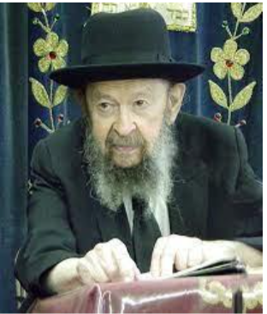
I don’t know what it means by ‘natural methods of healing’. If a person is using preventative methods, certainly. Prevention is always the best thing; to live normally beforehand as much as possible. But when a man sees chalilah something is wrong then there’s no other method except going to professionals. And Hakadosh Baruch Hu puts His stamp of approval on that: [doctors should have the ability to heal] (Bava Kama 85a).
Now, the language of reshus is a queer thing. Permission. You need permission to go to a doctor. Because how can a doctor have the boldness to tamper with a human body? The human body is so wonderful. What does the doctor know? He doesn’t know anything. And even today the doctors don’t know much about the body.
But Hakadosh Baruch Hu said, “Go anyhow. I’m going to help that they should not be too harmful for you.” Many doctors of course help people go quickly to the grave. Many doctors have facilitated people’s passage into the grave. But Hakadosh Baruch Hu says, “I’ll help out. You do your duty and I’ll help out.”
We look back today to the medicines of a hundred years ago and we’re horrified at the things they used to prescribe for patients. And still those who went in those days did a mitzvah of healing, you shall heal. So don’t rely on yourself but it’s a chiyuv of the Torah to heal yourself by those who are supposed to be capable of healing.
Reprinted from a recent email of Torah Avigdor based on a lecture delivered by Rav Miller on November 1988.

The Tragic Lesson of Lavan
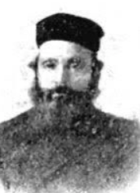
R’ Simcha Zissel Ziv

In an undated letter to his son, R’ Simcha Zissel Ziv z”l (died 1898) pointed out how great Lavan’s spiritual potential was and how low he stooped nevertheless. Lavan must have been agreat man, for the Torah mentions his blessings not once, but twice.
Before his sister Rivkah left to marry Yitzchak, he blessed her (24:60), “May you be myriads of thousands.” And, the Torah records that he blessed his daughters
before parting from them (32:1).
Lavan said to Yaakov (31:29), “It is in my power to do you harm.” And, since
Hashem had to appear to Lavan in a dream and warn him not to harm Yaakov, we can assume that Lavan could have harmed our Patriarch.
This also indicates Lavan’s greatness. [Presumably, only a great person could harm Yaakov.] Nevertheless, Lavan demeaned himself in ways that he never would have had he known that the Torah would record them.
These statements reveal his true character. He said to Yaakov, for example (29:14), “Nevertheless, you are my flesh and blood!” At first glance, this is a praiseworthy sentiment, but what did Lavan mean by the word, “Nevertheless”?
He meant, “I would have preferred that my relatives bring me gifts; nevertheless, you are my flesh and blood, so I will take you in.” (Even so, Rashi notes, Lavan immediately put Yaakov to work as a shepherd.)
Lavan was great enough to acknowledge to Yaakov (30:27), “Hashem blessed me because of you.” The same Lavan said (31:43), “The sheep are my sheep, and everything that you see is mine.”
Lavan observed the laws of family purity even more strictly than we do (see Ramban to 31:35), yet he frantically searched for his lost idols.
What is the lesson that we can learn from Lavan? It is: “One deficiency can ruin a great deal of good” (Kohelet 9:18). Lavan’s greatness did not save him from falling to a very low level. (Ohr Rashaz No. 143; also printed in Chochmah U’mussar No. 106)
The verse from Kohelet quoted above can also be translated, “One sinner can ruin a great deal of good.” R’ Simcha Zissel writes: This is why Chazal say, “Distance yourself from a bad neighbor.”
To what may this be likened? To one person who carries a deadly illness. All alone, he can wipe out an entire city. The same is true of a person who is spiritually ill. (Chochmah U’mussar No. 231)

Reprinted from the Parshat Vayeshev 5786 email of Yedidye Hirtenfeld’s whY I Matter parsha sheet for the Young Israel of Midwood in Brooklyn.

The Jewish Approach
to Life after Death
By Rabbi Benjamin Blech

Recently there's been a spate of new books presenting what the authors consider an unshakable case for the survival of consciousness beyond death, drawn from quantum mechanics, neuroscience and moral philosophy.
But I have to confess that having the inside information Judaism gave me – long before the publication of these new findings that claim to know what happens after our “full life of 120” – is far more satisfying than the most compelling and supposedly scientific validity for belief in an afterlife.
True, Jewish tradition never emphasized or even went into great detail about the specifics of the World to Come. It was simply a given, a fact rooted, as biblical commentators explained, in the notion that we are created “in the image of G-d.” Since G-d is eternal, there is something within every one of us – the Divine essence that represents our identity and that we refer to as our souls – that must of necessity be equally eternal and immortal.
The soul accompanies our journey through life, and does not forsake us with the end of our physical being.

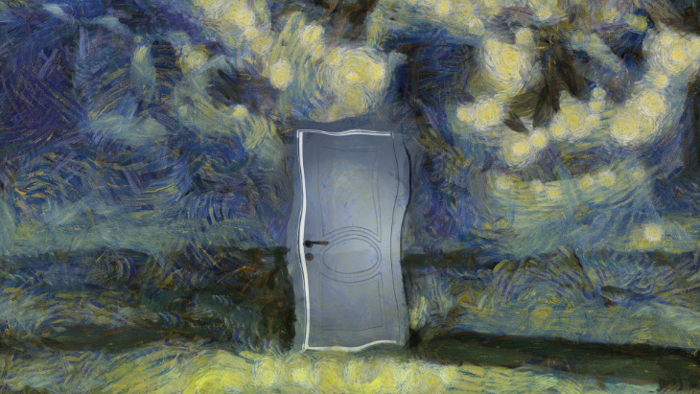

Our bodies, as material creations, came from the dust of the earth and have to return to their source; they disintegrate when they are buried. But our souls are the gift of “Himself” that the A-mighty breathed into us. They accompany us in our journey through life and do not forsake us with the end of our physical beings.

“Sure, There is Life After Death…”
Judaism did not dwell on the obvious. Sure, there is life after death; without it, life would be rendered a transient flash in the pan, perhaps fun while it lasted but ultimately devoid of meaning. The Torah recorded the past as history; it chose to leave the future as mystery. Its purpose was primarily to be a “tree of life” concerned with teaching us how to improve ourselves and our world while we inhabit it. The details of our post-terrestrial existence were in the main left unrecorded. There will be time enough for us to discover the Divine master plan for the World to Come – once we get there.
But if we are to lead our lives with the proper sense of responsibility and purpose, there are some things that the Sages realized we have to know about. So, they did give us a peek into the future after our deaths.
At the moment of death, we catch a glimpse of G-d. The Torah teaches us that G-d decreed, “No man can see Me and live” (Exodus 33:20). The implication is clear: with the end of life, we are granted the gift of a minute vision of the A-mighty. That is the reason, many commentators suggest, that we are obligated to close the eyes of the deceased. The eyes that have now beheld G-d Himself must be shut off from any further contact with the profane.

A Momentary Meeting that Gives
Meaning to All of Our Lives
And it is this momentary meeting that serves to give meaning to all of our lives. We suddenly grasp that everything we have ever done or said was in the presence of a Higher Power. Everything we accomplished or failed to do was judged by the One Who created us. “Know before whom you are destined to give a final accounting” is the language of the Talmud. Can there be a greater incentive to do good and not evil than the knowledge that in the end it is G-d Who will pass judgment on whether we were a success or a failure?
In Kabbalah, the mystics add a small piece to the story. It is not only G-d who judges us. As we bid farewell to the world, we are shown a film that contains scenes of our entire lives. We are witnesses to every moment of our days on Earth as they pass before us with incredible rapidity. And as we watch our own story unfold, there are times when we cringe with embarrassment; others when we smile with glee. Our past moral lapses cause us to shudder in pain; our victories over our evil inclinations provide us with a keen sense of spiritual triumph. It is then that we realize in retrospect that we alone are the greatest judges of our own lives. What happens after death is that we gain the wisdom to evaluate our own life by the standards of Heaven – because we have finally glimpsed an eternal perspective.

The Eternal, Here and Now
There is a synagogue in Jerusalem with a most unusual architectural feature. Built into one of the walls facing the congregants is a coffin. When I visited and remarked upon this seemingly morbid addition, one of the elders explained to me that this was a tradition their community maintained for many centuries. It had its roots in an effort to remind everyone of the cardinal truth that, being mortal, we are all destined someday to face our Maker. No one is exempt from the final judgment. To place this in the forefront of our consciousness every day, he smilingly said to me, is not morbid but surely a mitzvah.
No, we do not need to know the details of the World to Come. But we must constantly be aware of the reality that our days will be scrutinized by a Higher Authority – and that we ourselves will be forced to join in the Divine judgment.

We Can Hazard a Guess
There is no clear picture painted for us of Heaven and Hell. While belief in reward and punishment after death is, according to Maimonides, one of the 13 major principles of our faith, we have no way of knowing exactly what is meant by this concept. But we can hazard a guess. Since our entry into the next world is preceded by the obligation for every one of us to watch the film record of our lives, what greater Hell can there be than for us to have to acknowledge our shameful actions and our unconscionable failings unto all eternity? And what greater Heaven can there be than the ability to look back forever on personal acts of goodness, of charity, and of noble and pious behavior that made us find favor in the eyes of G-d?
That's why it's so important for us to affirm that death isn't the end. And even if we don't know exactly how our souls will be treated either above or below, we have been assured that the righteous are guaranteed rewards commensurate with their good deeds, and the wicked will rue the evil they perpetrated.
What is Hell? Remember when you were in eighth grade and something utterly embarrassing happened? The shame you felt and how you just wanted the ground to open up so you could disappear. That is Hell. It is the deepest realization that our life (or part of it) has been squandered, which creates a deep regret and shame in our soul.
The good news is that G-d – in His infinite kindness – established this as a cleansing process, where after one year (or less), all the negativity has been forever washed away.

Closing the Curtain
So why think about what happens after death while we're still here? The answer is simple and at the same time most profound: Whatever actions we take on Earth must be with a sense of their eternal ramification.
Perhaps it's best reflected in the following story. A very wealthy man not known for his piety stood in a long line of those waiting to have their lives assessed by the heavenly court. He listened attentively as those who were being judged before him recounted both their spiritual failings and achievements. A number of them seemed to have the scales weighted against them until they suddenly remembered acts of charity they had performed, which dramatically tipped the scales in their favor. The rich man took it all in and smiled to himself.
When it was his turn, he confidently said, “I may have committed many sins during my lifetime, but I realize now what has the power to override them. I am a very wealthy man and I will be happy to write out a very large check to whatever charity you recommend.”
To which the court replied, “We are truly sorry, but here we do not accept checks – only receipts.”

The True Tragedy of Death
The true tragedy of death is that it represents the closing curtain on our ability to do anymore mitzvot. We no longer have the free will to do good (or evil). It is only what we bring to that moment that can earn us entry into a state of eternal bliss. It's what we do here and now that truly matters. The choices we make today create our portion in the Next World. For eternity.
Death isn't a destroyer; it's a transition. As the chassidic Rabbi Mendel of Kotzk put it, “Death is just a matter of going from one room to another. And if we live our lives in accord with the will of G-d, we are certain that the place we are going to is ultimately the more beautiful area.”
Yes, there is life after death. But the greatest afterlife is achieved by focusing on how we can maximize our life before death.

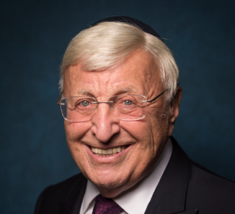

Rabbi Benjamin Blech, a frequent contributor to Aish, is a Professor of Talmud at Yeshiva University and an internationally recognized educator, religious leader, and lecturer. He is the author of 19 highly acclaimed books with combined sales of over a half million copies.

Reprinted from the current website of aish.com
New Life for
100-Year-Old Tefillin


Ethan James puts on his great-grandfather's tefillin, with the help of Rabbi Yosef Goldwasser.

Join us in wishing mazal tov to Ethan James, who just put on tefillin for the first time, using the pair that had belonged to his great-great grandfather, Wilhelm Sterling.
Wilhelm was born in Russia in 1902 and lived and worked in New York. When he passed away, his tefillin, which may have belonged to his father before him, were lost for decades.
In recent years, his granddaughter, Rachel Leah Fry, who lives in Daphne, Alabama, was fortunate to finally come into possession of both the tefillin and a tallit of his (which is not nearly as old).

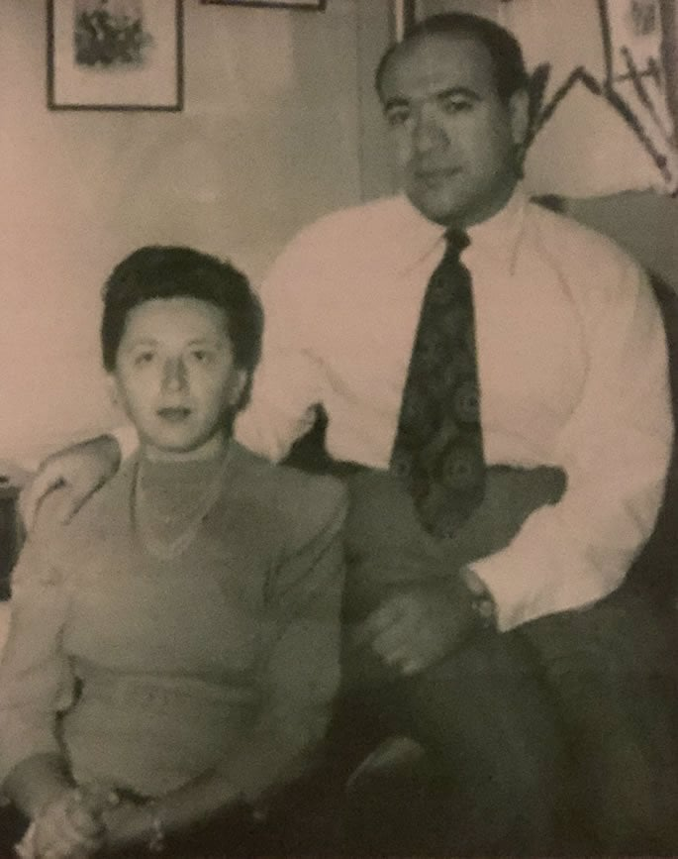
Ida and William Sterling.

With the help of Chabad Rabbi Yosef Goldwasser, she had the tefillin checked by an expert scribe, and they were still 100% kosher.
Having no male family members who practice Judaism, she was afraid the tefillin would lie dormant forever.
But when her daughter and 17-year-old grandson, Ethan, came to visit for Thanksgiving, the rabbi asked Ethan if he would be willing to wrap tefillin and say the prayers. Ethan agreed.
“There is no way to express how much joy this engendered in me to see those tefillin wrapped and hear the prayers said by my precious grandson,” says Rachel Leah. “It was like seeing those boxes take on life. And while my grandson does not currently practice Judaism, he is Jewish, and I pray this experience will be the awakening of his neshamah. I came back to Judaism late in my life, so hope lives within me that he may someday find in himself a similar awakening.”

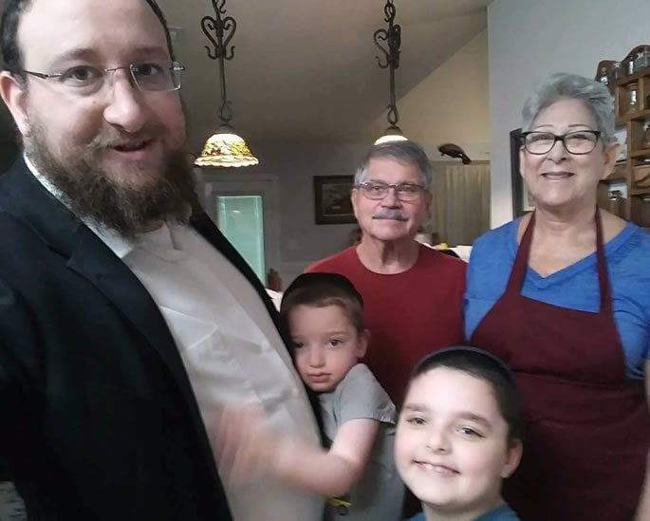
Rabbi Yosef Goldwasser and his sons Mendel and Berel help Rachel Leah Fry kosher her kitchen.

Reprinted from the current website of Chabad.Org

The Importance of Never Stagnating

These are the generations of Yakov, Yosef (37:2) The name Yosef comes from the Hebrew meaning to add or increase. Yakov is symbolic of every Jew. The lesson to be derived is that a Jew must never allow himself to stagnate, but must always climb upward along the spiritual "ladder" of Yiddishkeit. (Rabbi Menachem Mendel of Riminov)

Reprinted from the Parshat Vayeishev 5786 email of R’ Yedidye Hirtenfeld’s whY I Matter parsha sheet for the Young Israel of Midwood in Brooklyn.

